Hematopoiesis (Myeloid cells)
By Yogeshwari Tiwari
Department of Biotechnology
Govt. Digvijay Autonomous P.G. College, Rajnandgaon
Hematopoiesis is the vital process of forming all cellular components of blood (red cells, white cells, platelets) from hematopoietic stem cells (HSCs), primarily in the bone marrow, ensuring a continuous supply for oxygen transport, immunity, and clotting.
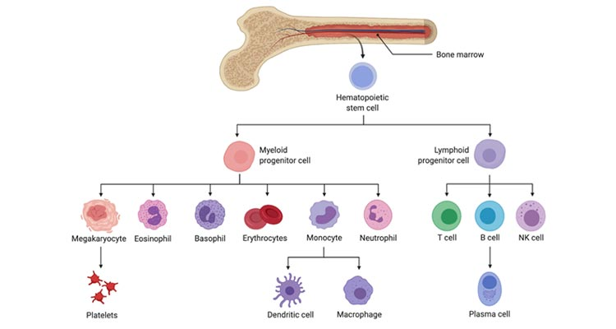

Myeloid cells
Myeloid cells are a diverse group of white blood cells, including neutrophils, eosinophils, basophils, monocytes, and dendritic cells.
They respond quickly to infections, present antigens, and can also become immunosuppressive or promote tissue repair, playing significant roles in both immunity and diseases like cancer.
Neutrophils
Neutrophils are 60% part of total leukocytes.
It contains a triploid nucleus.
Their half-life is 5.5 days in free form, but when they bind with antigen, their half-life decreases to 1.5 days
They show phagocytic activity in blood.
They contain two types of granules _
primary granules - Lysozyme, hydrolases, myeloperoxidase, etc.
Secondary granules - Iron chelators, Lactoferrin, and digestive enzymes.
Neutrophils contain IgG antibody on their surface, and they first arrive at the infection site.
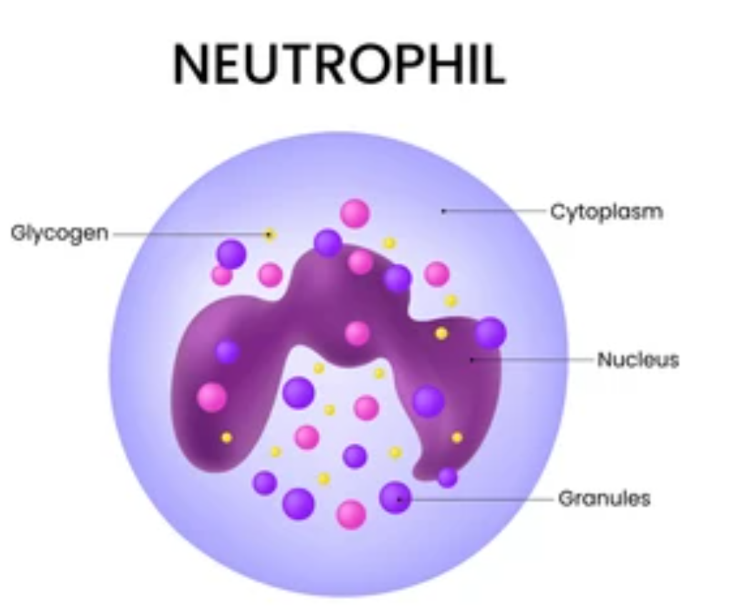

Basophil
It is less than 1%of total WBCs
They are non-phagocytic in nature.
They contain a bilobed nucleus and granulated cytoplasm.
They contain IgE antibody on their surface.
They play a major role in allergic reactions.
During hypersensitivity, they release heparin and histamine through the granules.
Heparin- an anticoagulant enzyme
Histamine - pore-creating enzyme.
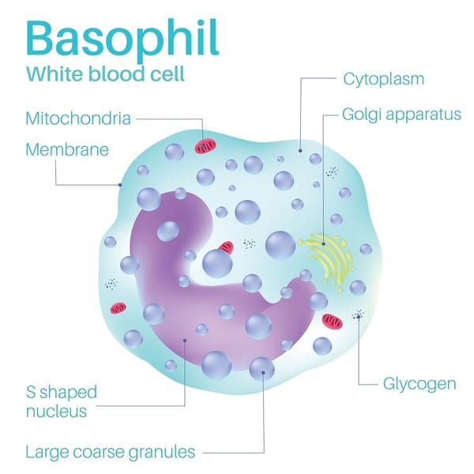

Eosinophils
It is a 1 -3% part of the total WBCs.
They contain a bilobed nucleus and granulated cytoplasm.
They also contain IgG and IgE antibodies on their surface.
They play a major role in parasitic infection, but are less phagocytic than neutrophils.
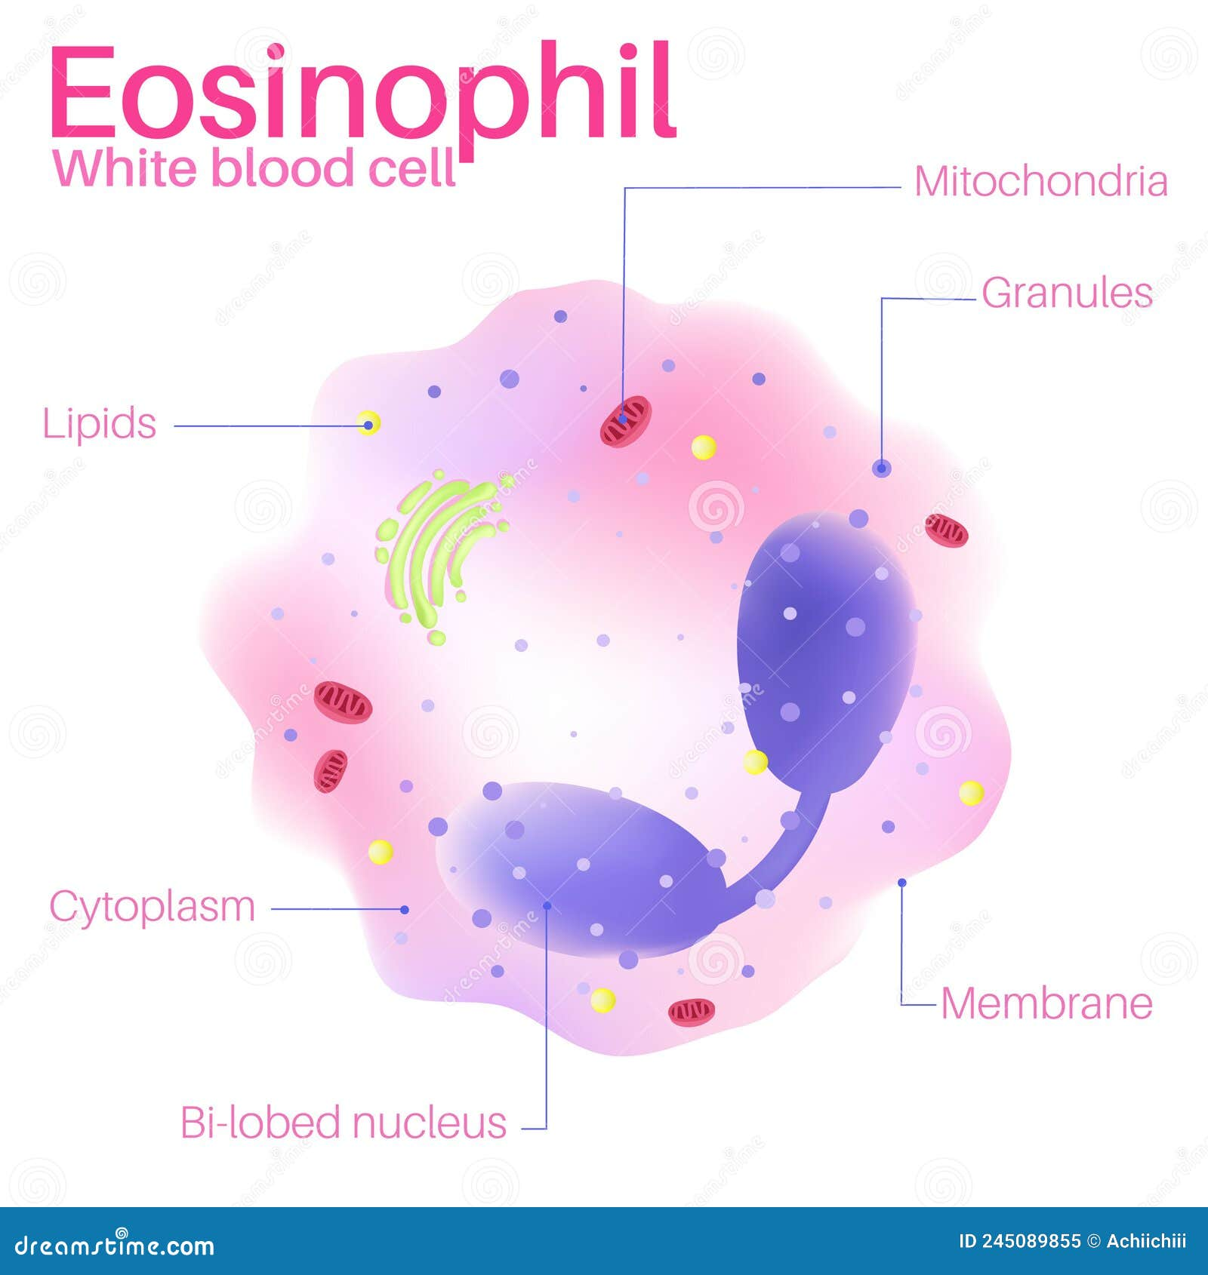
Functions of immune cells
Innate immunity - shows a rapid response against infection.
Antigen presentation - macrophages and dendritic cells work as antigen-presenting cells.
Inflammation regulations - Can be pro-inflammatory or anti-inflammatory.
Tissue maintenance and repair - Helps to clear dead cells and wound healing.

